# Elementor CGP Widgets

Last updated: May 31, 2021

Custom WordPress plugin that houses custom Elementor Widgets. The main purpose of these widgets is to provide accessibility.

The plugin currently makes the following widgets available via the Elementor page builder. The easiest way to find the widgets is to type “CGP” in the search Elementor widget search bar:

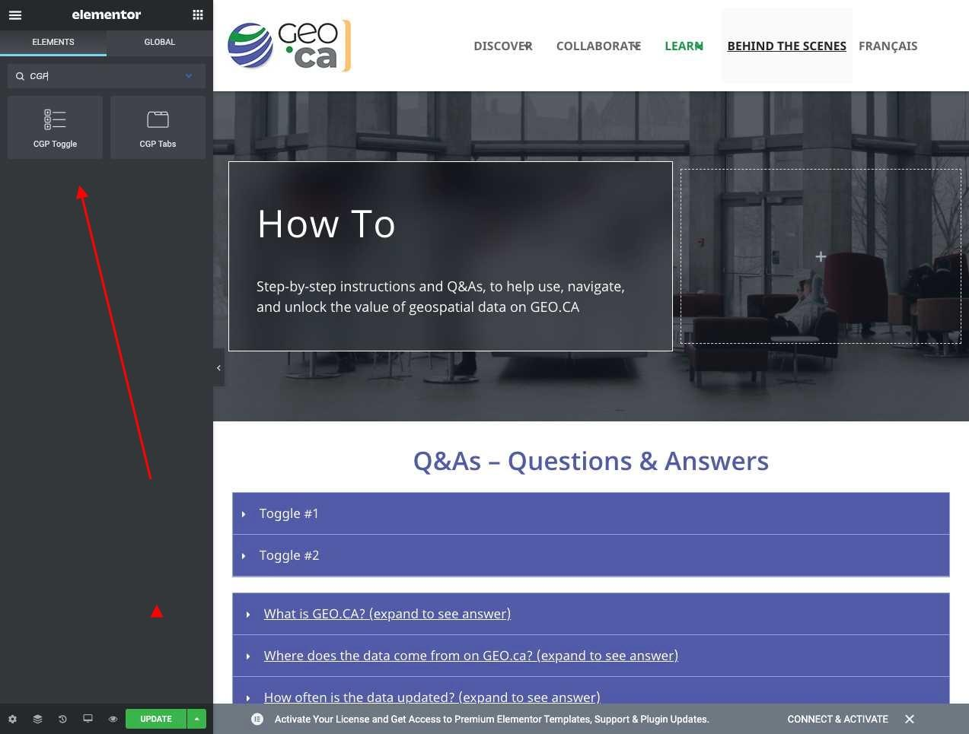

## 1 - CGP Toggle

Almost identical to the native Elementor “Toggle” widget.

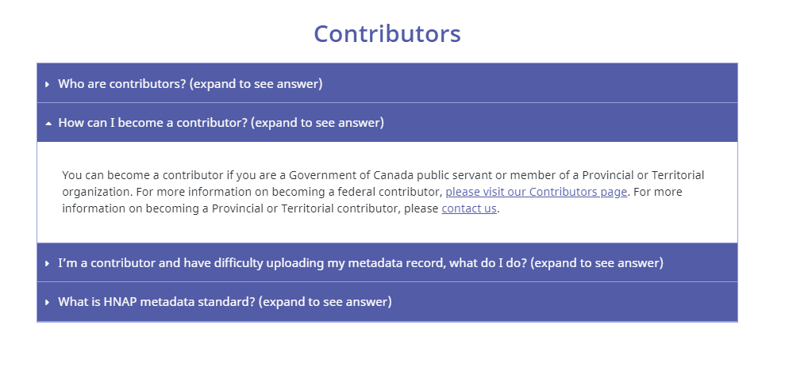

## 

## 2 - CGP Tabs

This is based on the native Elementor “Tabs” widget. However, it has only been tested to display CGP API shortcodes.

